**Table of Contents**

1 Introduction 3

1.1 Company Background 3

1.2 Project Background 4

1.3 Assumption 4

1.4 New Proposed Management System Business Process Overview 4

2 Problems and Proposed Solution 6

2.1 Problems with Cause and Effect 6

2.1.1 Problem Background 6

2.1.2 Issues Identified 6

2.1.3 Problem Statement 6

2.2 Proposed Solution 6

2.3 Aims and Goals 7

2.3.1 Goals 7

2.3.2 Aim 7

2.4 Objectives 7

3 Project Planning 8

3.1 Software Development Life Cycle (SDLC) 8

3.1.1 Planning 8

3.1.2 Analysis 8

3.1.3 Design 9

3.1.4 Implementation 9

3.1.5 Security and Support 9

3.2 Gantt Chart 10

3.3 Workload Matrix 11

4 Feasibility Report 12

4.1 Operational Feasibility 12

4.1.1 Performance 12

4.1.2 Information 12

4.1.3 Economy 12

4.1.4 Control 12

4.1.5 Efficiency 12

4.1.6 Services 12

4.2 Technical Feasibility 13

4.3 Economical Feasibility 13

4.4 Schedule Feasibility 15

5 System Analysis 16

6 Design Diagram 18

6.1 Context Diagram 18

6.2 Level - 0 DFD 18

6.3 Entity Relationship Diagram (ERD) 19

7 Interface Design 20

7.1 Screen Shot of the Program 20

8 Requirement Gathering 30

8.1 Observation 30

8.2 Interview 31

8.3 Surveys and Questionnaires 33

8.3.1 Way to Conduct 34

8.4 Research 35

8.4.1 Way to Conduct 36

8.5 Sampling 37

8.6 Document Review 38

8.6.1 Way to Conduct 39

9 Individual Design 40

9.1 DFD Level - 1 40

9.2 Data Dictionary 44

10 References: 49

11 Appendix 51

11.1 Workload Matrix (Group Members’ Names) 51

# Introduction

## Company Background



**Atlas** Sdn. Bhd. Started as a system analyst and designing company that strives to give their client their best result based on the time and budget that was given in the project to the company. Founded on 2015, Atlas Sdn. Bhd. has worked with various industry of different business fields and has each completed and solved the problem that was presented to the company. Atlas Sdn. Bhd. began as a company that solves Problem with creating a software suited to the client, but as we grew, we helped industries with training their staff with a special program, building data server for the future of the client and many more. We have further expanded our services internationally and solved many foreign client issues over the past years.

**Our Motto** : *Efficiency is our Pride*

**Our Vision** :

To be the trusted and depended developer organization locally and     internationally that delivers our job with the utmost efficient manor

**Our Mission** :

To provide our clients with the efficiency in their business with our solution and bringing comfort to both our clients and their loyal customers

## Project Background

Throughout the years, the fitness centre has acquired more customers and members for their monthly subscription of the fitness centre’s utilities. In that period, the manager has observed and figured out that their current system isn’t well planned out and prepared for a large dataset of their current members and large quantity of the product’s sales in a short period of time. The current system seems to be decreasing the efficiency and workflow of the staff and managers of the fitness centre. Thus, Atlas (Our company) was hired to analyse, examine and come up with a solution that increases the workflow efficiency and overall performance of the staff and managers of the fitness centre to better handle the large amount of current and future members, and an overall dataset of sales.

## Assumption

  With Berjaya Fitness Centre growing in amount of member significantly, it is justifiable to assume that Berjaya Fitness Centre keeps track of their members data (Name, Age, Subscription, etc.) and sales data (inventory, price, etc.) in a paper-based system which is not secure nor efficient in the long run. The reports and the maintenance of the gym’s equipment are scheduled by a staff manually. Since the data is all in paper-based forms, we assume that the staff is having a hard time sorting through the data, when the staff needed a specific member’s data. The staff couldn’t have had training of using a specialized software to keep track of all the data in the gym, considering that they haven’t used software for their data before. The gym also can’t tell the members if a class of the gym is full or not, and trainers have no way to know of their pupils’ diet and calorie intake without asking them directly.

## New Proposed Management System Business Process Overview

* Customer A enters the gym.

If customer A is a member, he/she has to scan the member ID on the entrance barrier.

* ID that has been scanned will be recorded in the database for security reasons, in and out.
* If customer A isn’t a member, the receptionist will ask for the customer’s ID and offer 3 days free trial to the gym.
* The gym will provide a free towel for the customer to use in the gym and has to be returned before exiting the gym.
* Keys to locker are left hanged onto the locker, so customers can choose lockers.
* If there are issues on the gym equipment, customers can tell a staff nearby or place a feedback in the app.
* If a customer buys a product that is sold in the gym, the staff will input the sales into the database.
* Customer A will be reminded of their exercise hours in their app

# Problems and Proposed Solution

## Problems with Cause and Effect

### Problem Background

Every week in Berjaya Fitness Centre, the workers have to prepare the weekly sales reports on number of members & earnings and check the inventory for the facilities manually which is consuming a lot of not only time, but also energy. As time goes by, the quantity of members who joined the fitness centre has been escalating and that made the current manual system it operates is not as efficient as it used to be. Therefore, Mr. Halim hire professional system developer (Our Company, Atlas) to bring him out from the ongoing situation his business facing

### Issues Identified

* Handwritten and paper-based system to store all the members data
* On the spot facilities inventory checking by a staff
* Technology literate staff that requires short-term training on how to use the new system
* The increasing number of members
* The data integrity is not guaranteed

### Problem Statement

* More and more people have joined Berjaya Fitness Centre which causes the current manual data storing system is not working efficiently to run the business.

## Proposed Solution

We proposed a software solution that has the capabilities to have the user input data about Berjaya fitness centre daily sales and storing the data into a database which is only accessible by authorized staff. Additionally, the software could check on the stock and inventory of the items sold in the store. If the item requires a restock, the software will automatically detect it and calls a supplier and buys the items in bulk. There will also be another software for the members of Berjaya fitness centre, that will be able to count the number of calories a member has ingested according to the input by the user (the member) and sends that data to his/her personal trainer to keep track of their body intakes. It has a feature which can see if a room is still available for a member to go in and join a class (yoga, etc). It will inform a staff when several member complaints have been reaching on a certain gym equipment. After a staff has confirm the faults of the equipment, the staff can input the equipment’s detail and the software will automatically writes the equipment on a service schedule or call a repairman, if needed.

## Aims and Goals

The aims and objectives we want to acquire by our proposed system solution as follows:

### Goals

* Improve Berjaya Fitness Centre’s System Ability
* Increase Berjaya Fitness Centre’s System Features
* Improve Berjaya Fitness Centre’s Employee Skills

### Aim

To develop Berjaya Fitness Centre’s system ability and features as well as to improve their employee skills.

## Objectives

* Facilitating the employees in preparing weekly sales reports and the inventory records with a software that allow them to enter the value and then it will be inputted automatically into database
* Reducing the time that is used to check the facilities and place request for services through customer complaints service
* Adding new features needed for the fitness and health centre such as rooms & classes availability schedule, calories loss tracker, member’s personal data, auto-generated message will be drop into one’s account if there’s new information ( for instance: bill notifications, some outstanding payments, etc.)
* To educate all the employees by conducting a short-term training program on how to utilize the brand new system

# Project Planning

## Software Development Life Cycle (SDLC)

### Planning

    System planning is the phase of developing a system which moves the company away from manual data collection which enables our company to manage orders, billing and inventory. System planning also involves planning in the budget to make sure the cost doesn’t exceed the budget allocated and to make sure the new system is completed in the time given. This phase is also done to analyse problems and propose solutions for it and do a preliminary investigation report.

TASK and ACTIVITIES:

* Mainly, is to improve efficiency of the company.
* Improving operations, so that it’s less time-consuming and its better ease for everyone who would need to use the system.
* System is paper-based. Won’t be or not going to be advisable for future use. As there is an increase in new customers joining the gym. So, making a move over to computerised based system.
* So, is there a need for a new system? Yes, there is a need for it.
* The new system would have to change according to requirements so that it can meet the goals of the company but more important being able to meet customer expectations.
* This system needs to be up and running after 8 months and needs to be in the budget of RM15,000.

### Analysis

System analysis main purpose is to build a logical model of the new system. It’s also the phase of doing a detailed investigation to find out the system requirements. it can be done by performing fact finding techniques such as surveys and interviews.

TASK and ACTIVITIES:

* Under-going fact-finding procedures so our company can understand more deeply how Dr. Willy runs his gym. Allowing us to produce an effective system.
* Speaking to the employees, having an understanding how the interact with the customers, the procedures which are taken when someone has just joined the gym.
* Asking the customers if they have any insights on the way the gym operates and how they may have opinions on which can have an effect on the gym.
* With this, we will notice the areas where there are problems and how we would be able to turn them into potential opportunities.
* As a result, from the information obtained, Atlas would have better idea for the system requirements document.

### Design

In system design, a physical model is created that has all the requirements for the new system. SRS is the input of design and the business model or process is known as design specification.

TASK and ACTIVITIES:

* This is where basically where our company has completed the design system processes.
* This would include all the necessary technical specifications.

### Implementation

    System implementation is when the system is constructed and installed. It’s the phase of coding and testing to see the result of the functioning system.

TASK and ACTIVITIES:

* In this stage, the hardware and software are installed. The new software with the applications which would be used for the everyday use of the employees of the gym.
* We would have to test the system in a series of cycles of coding, testing and debugging, until it is ready to be delivered.
* Once it’s been installed and tested, it’s best to review once more and to document it, as it will help us to review the system and find better ways in improving it in the coming future.

### Security and Support

    Security and support are the maintenance of the system which needs to be updated after a few years or replaced. A well-designed system must be secure, reliable, maintainable and scalable.

TASK and ACTIVITIES:

* Once the employees of the gym have started using the new system, if there’s any enquiries that they may have. Where to change or to have some better understanding of doing the reports, etc…

## Gantt Chart

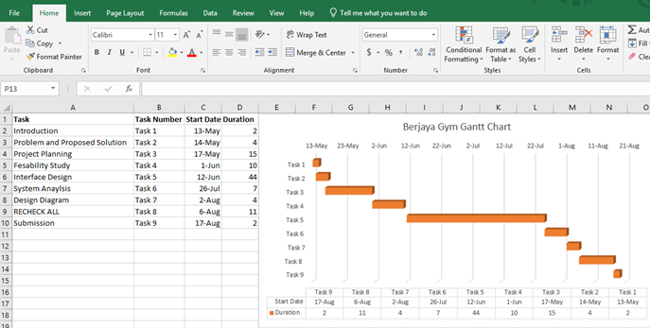

## Workload Matrix

|  |  |  |  |  |  |  |
| --- | --- | --- | --- | --- | --- | --- |
| Group Member | Jessica | Janice | Jean-Paul | Dakkshesh | Axell | Ricky |
| Introduction | **33.3%** | **33.3%** | **33.3%** | **33.3%** | **33.3%** | **33.3%** |
| Problems and Proposed Solutions | **33.3%** | **33.3%** |  |  |  |  |
| Project Planning |  |  | **33.3%** | **33.3%** |  |  |
| Feasibility Study | **33.3%** | **33.3%** |  |  |  |  |
| Systems Analysis |  |  | **33.3%** | **33.3%** |  |  |
| Design Diagram |  |  |  |  | **33.3%** | **33.3%** |
| Interface Design |  |  |  |  | **33.3%** | **33.3%** |
| **Total** | **100%** | **100%** | **100%** | **100%** | **100%** | **100%** |

# Feasibility Report

## Operational Feasibility

In accordance with operational feasibility, we will be using the PIECES framework, which consists of Performance, Information, Economy, Control, Efficiency, and Services, to carry out the report of our proposed system.

### Performance

As we know that our system can handle all current issues for instance, maintaining the member’s data and each person bills information, tracking the user’s activity in the fitness centre; digitally using computer. Therefore, the time needed to finish each task will be reduced and lead to better fitness centre performance.

### Information

The system we applied will keep the information concerning all members and employees of the fitness centre safely into a database that can be accessed only by authorized personnel only, hence giving an accurate and high secured data.

### Economy

By implementing the system, the old manual paper-based system will be taken down thus reducing unneeded cost for buying paper and its container. Not only that, company also can remove excessive workers because most of the job is done digitally.

### Control

Since the proposed system keep all the data in the database where only authorized personnel will know the password of the computer, thus the data is highly safe, secure, and well-protected.

### Efficiency

This system will lessen the time and energy used by each employee due to the ease of operating the proposed system. Furthermore, the staff that working on this section could have done more tasks and working much more efficient than before. Besides, staffs do not have to check the facilities on the spot to see whether it need services or not.

### Services

The current proposed system provides reliable yet flexible services such as enabling the staffs to edit, manage, delete the data related to the fitness center members or staffs from the highly secured database in the administrator computer.

## Technical Feasibility

The proposed solution is more practical because everything that used to be done manually has been programmed into a software, therefore time that is wasted in managing the system can be reduced and work will be more efficient for both employees and customers. The technology that is necessary for the system can be found easily around the city and some of it is already possessed by the gym. Layout of the interface will be made as user-friendly as possible, so the employees and customers can easily learn services that are provided by the system. Since the functions of the system are easy to learn, both users will be able to master it in no time.

## Economical Feasibility

From the Cost-Benefit Analysis table evaluation, the value of benefits gained is estimated to be greater than the costs of the proposed system’s operational and development cost. The benefit obtained is exceeding the amount of projected cost in the end of year three after the new system implementation. Some intangible benefits acquired from the digitized system for instance time-saving, more protected data and ease are inevitable. Besides, the entire cost of the project does not surpass the budget designated by Berjaya Fitness Center. Thereupon, this proposal is economically feasible where the budget meets the development cost perfectly.

The Development and Operational Cost table along with Cost-Benefit Analysis table will be shown in figure 4.3.a and 4.3.b.

|  |  |  |  |
| --- | --- | --- | --- |
| **Name** | **Quantity** | **Cost per Unit** | **Total** |
| Computer + Peripherals | 3 | RM   1,000.00 | RM   3,000.00 |
| ID Card | 500 | RM   1 | RM   500.00 |
| ID Card Reader | 1 | RM   130.00 | RM   130.00 |
| Server | 1 | RM   4,500.00 | RM   4,500.00 |
| Power Outlet Cables/metre | 50 | RM   1.50 | RM   75.00 |
| LAN Cables/metre | 50 | RM   0.80 | RM   40.00 |
| System Developer Cost |  |  | RM   1,255.00 |
| Staff Training Fee |  |  | RM   500.00 |
| **Total Development Cost** |  |  | **RM   10,000.00** |
| System Maintenance |  |  | RM   100.00 |
| Software License Fee |  |  | RM   200.00 |
| **Total Operational Cost** |  |  | **RM   300.00** |
| **Total Operational Cost per Year** |  |  | **RM   3,600.00** |

***Figure 4.3.a: Development and Operational Cost Breakdown***

|  |  |  |  |  |  |  |
| --- | --- | --- | --- | --- | --- | --- |
| **Cost-Benefit Analysis** | | | | | | |
| **Costs** | **Year** | | | | | |
| **0** | **1** | **2** | **3** | **4** | **5** |
| Development    costs | RM 10,000.00 | RM   - | RM   - | RM   - | RM   - | RM   - |
| Operating costs | -RM   - | -RM 3,600.00 | -RM 3,600.00 | -RM 3,600.00 | -RM 3,600.00 | -RM 3,600.00 |
| **Total costs** | -RM 10,000.00 | -RM 13,600.00 | -RM 17,200.00 | -RM 20,800.00 | -RM 24,400.00 | -RM 28,000.00 |
| Discount factor  (discount rate=8%) | 1 | 0.9259 | 0.8573 | 0.7938 | 0.735 | 0.6806 |
| Present Value  of Costs | -RM 10,000.00 | -RM 3,333.24 | -RM 3,086.28 | -RM 2,857.68 | -RM 2,646.00 | -RM 2,450.16 |
| Cumulative  PV Costs | -RM 10,000.00 | -RM 13,333.24 | -RM 16,419.52 | -RM 19,277.20 | -RM 21,923.20 | -RM 24,373.36 |
| Benefits | RM   - | RM 12,000.00 | RM 12,000.00 | RM 12,000.00 | RM 12,000.00 | RM 12,000.00 |
| **Total benefits** | RM   - | RM 12,000.00 | RM 24,000.00 | RM 36,000.00 | RM 48,000.00 | RM 60,000.00 |
| Discount factor (discount rate=8%) | 1 | 0.9259 | 0.8573 | 0.7938 | 0.735 | 0.6806 |
| Present Value of Benefits | RM   - | RM 11,110.80 | RM 10,287.60 | RM 9,525.00 | RM 8,820.00 | RM 8,167.20 |
| Cumulative PV Benefits | RM   - | RM 11,110.80 | RM 21,398.40 | RM 30,923.40 | RM 39,743.40 | RM 47,910.60 |
| Cumulative PV Benefits + Costs | RM 10,000.00 | -RM 2,222.44 | RM 4,978.88 | RM 11,646.20 | RM 17,820.20 | RM 23,537.24 |
| **Benefits > Costs** | RM 10,000.00 | -RM 1,600.00 | RM 6,800.00 | RM 15,200.00 | RM 23,600.00 | RM 32,000.00 |

***Figure 4.3.b: Cost-Benefit Analysis Table***

## Schedule Feasibility

The proposed system that we are going to implement in Berjaya Fitness Centre to replace their manual system and increase the performance of the fitness centre will be finished on time. Based on the Gantt Chart, required time to do the system design process starting from planning to implementation and testing is about 5-6 months if there is no delay in the process. Therefore, we can replace the time-wasting manual system within the estimated timeline given by the owner of the fitness centre.

The system is also designed to be more efficient after it is implemented in the fitness centre since the system has features to store the fitness centre daily sales in database which will reduce time that is wasted in inputting data manually. The fitness centre also has features to check on stock and inventory of the items sold in the store and automatically contact suppliers if the items are out-of-stock which will reduce time-consuming process for the employees to check the stocks every week. Since all data are store in the database, the employees can find data manage everything easily without having to do it the manual way like filtering through paper records.

# System Analysis

System analysis focuses about the requirement gathering of the newly designed software for Berjaya Fitness (BF). From the findings of requirement gathering, it’s required to create a list of requirements which includes functional and non-functional requirements for this new software of Berjaya Fitness. Requirement Analysis is the way of characterizing the desires for the users for an application that will be constructed or altered. The requirements of systems should be appropriate, detailed and computable. There are two types of requirements which can be broken down into functional requirements and non-functional requirements.

Functional requirements simply mean that any requirement that details clearly on what the system must do. To put it in simple terms, when certain criteria is met, a functional requirement will portray a activity or function of an element of the new system. The non-functional requirement on the other hand means any requirement that details on how the system should carry out a function. It’s also often called as “quality attributes”. The non-functional requirement’s different expressions are “quality of service requirements, goals and non-behavioural requirements”.

List of functional requirements.

1. Administration office staff should be able to register new customers that wants to join the gym by using this system.
2. To obtain full information about them which would include name, phone number, when will the next payment for the gym subscription be. Whether they have selected personal bookings with trainers as well.
3. The system should make note of how many non-members is being exercising at Berjaya Fitness, so the weekly sales report is accurate.
4. The customer will be notified when they need to make the next payment that the system would generate.
5. Once the customer has paid, a receipt will be printed, and the customers record would be updated.
6. The system is user-friendly so that it is easy to use for the employees at Berjaya Fitness
7. If there is any complaints or feedback from the customers, the system would gather the information and be stored in a separate place. Once the management does its reviews, they would be able to go through it. The information would be sorting from the most important to the least. And only if they need to, the gym can contact a repairman to fix any issues. E.g. any faults with a machine.
8. As for inventory, once these items come into the gym, it is recorded and stored. This would be improving the tracking of how many items remains in the gym.
9. If the inventory needs re-stocking, the system would send a notification to the management and then from then on, the management contacts the supplier and place orders for the desired product.
10. Another part of the software would be for the members. This would allow them to track the number of calories the member has ingested and would be sent directly to their personal trainer. It would also have a special feature, which would allow them to see if a room is still available for a member to go and use.
11. Most importantly, being able to aid the employees in preparing weekly sales reports. Improving efficiency and reducing any errors.
12. User IDs and passwords should be giving to those would work on the system itself.

List of non-functional requirements

1. This system would be only up and running during business hours
2. The systems should be able to update if there are any issues that is found. It should be 100% reliable and maintainable.
3. The information of members should be kept private or only viewable to the appropriate personal.
4. Unpaid members are not allowed to gain access to the facilities.
5. A recovery plan of 30 minutes will be giving if the system has a fall out.

# Design Diagram

## Context Diagram

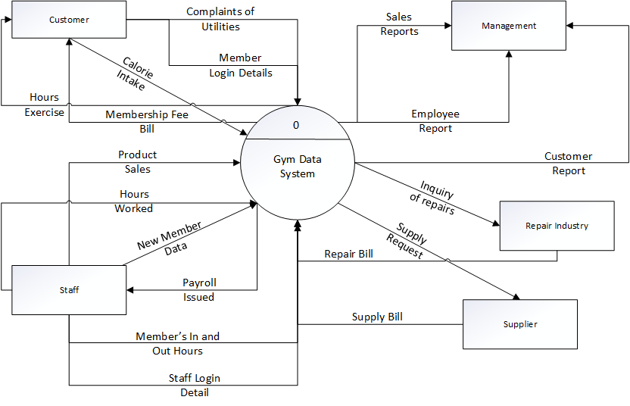

## Level - 0 DFD

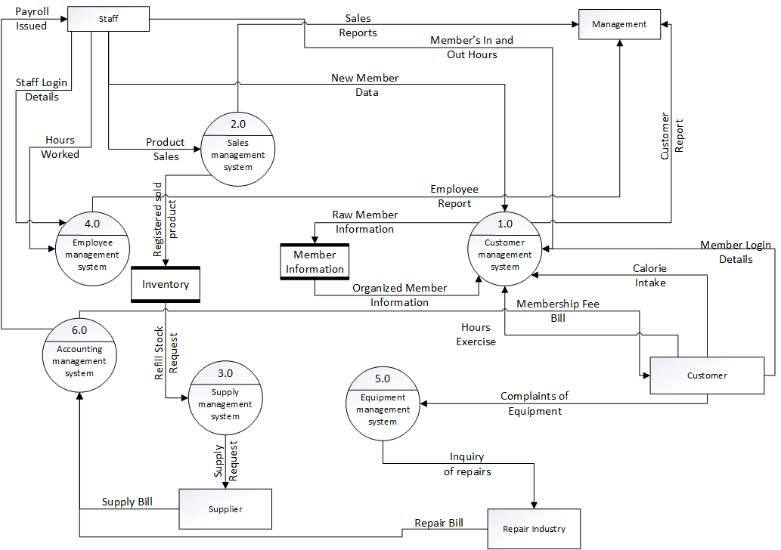

## Entity Relationship Diagram (ERD)

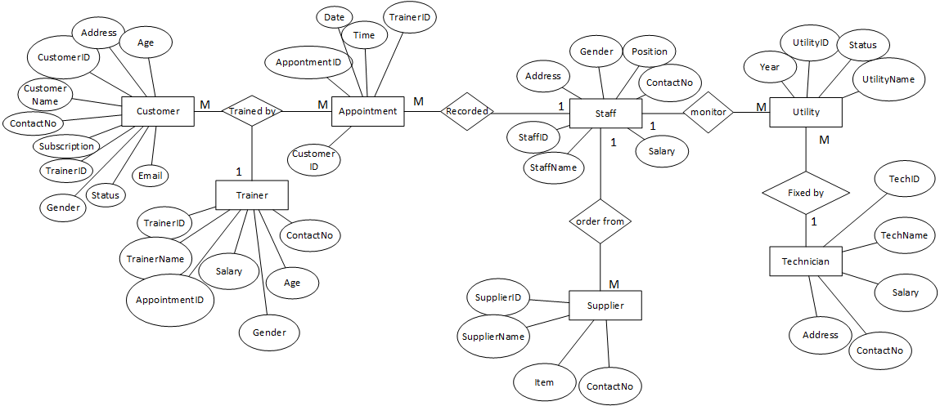

# Interface Design

## Screen Shot of the Program

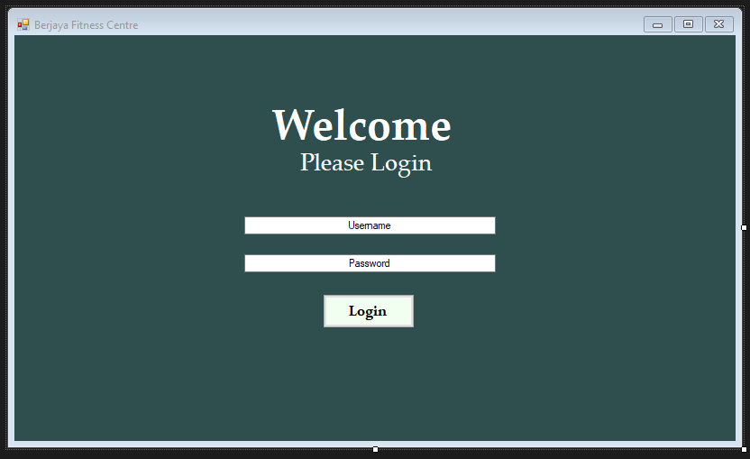(7.a Login Page)

This is how the login page will look like where the staffs can input their ID so we know who used and input all of the items in the program. This can also ensure no stranger can access the program. Different User will be directed to a different page based on the type of user they are. (Example : a staff will be directed to the Staff Home Page once Logged in)

**Interface for Gym Members**

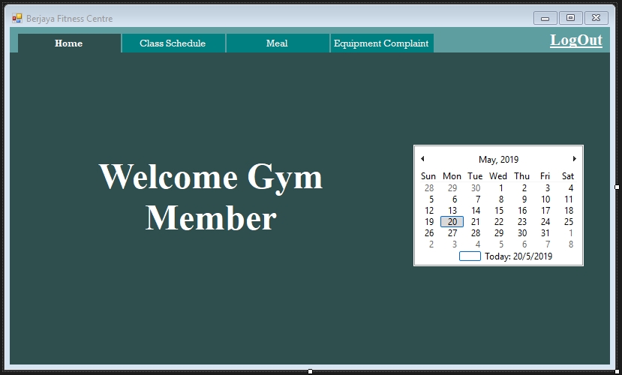

(7.b Member Home Page)

This is the Home page for the gym members where the program will show the current date they access it. This date will automatically be scanned by the program so the user doesn’t have to enter it again in the next windows if its needed.

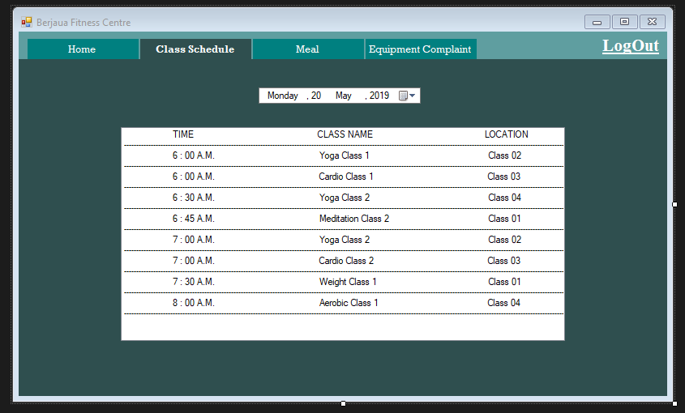

(7.c Member Class Schedule Page)

Class schedules of the gym are also listed down in it so that the members keep updated of any new workout programs in the gym. The list will be updated everytime a trainer adds new schedule in the trainer’s window.

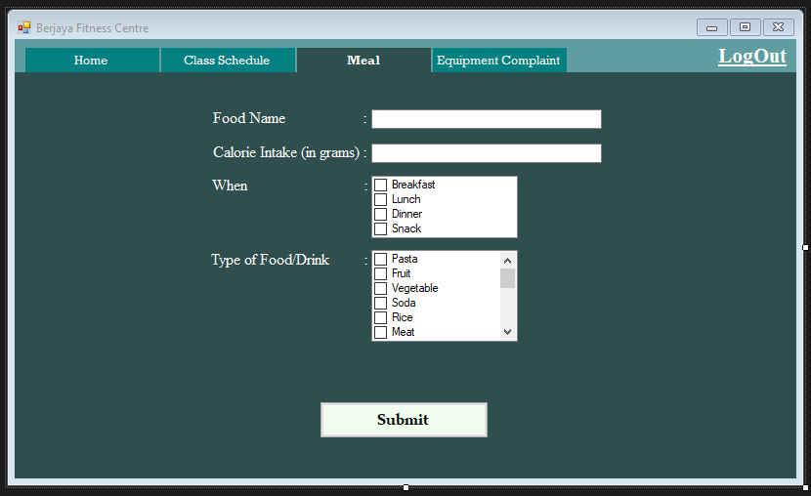

(7.d Member Meal Input Page)

This window is used to inform the gym trainers about the calories that the gym members had eaten on that specific day.

**Output:** Information that are entered by the member here will be sent to their personal gym trainer’s database.

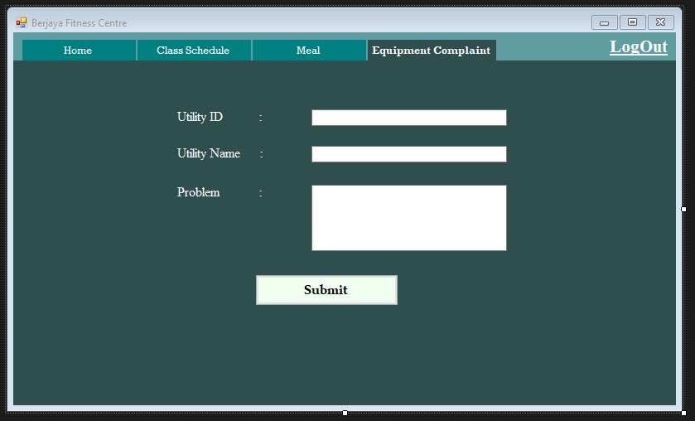

(7.e Member Equipment Complaint Form Page)

Gym equipment are often broken because of everyday usage. So, this is where the gym members can give complain about which facility and what damage that need to be fixed.

**Input:** Utility ID and Name that can be found on the sticker that have been attached to each and every facilities.

**Output:** Complaints will be shown on the complaint window on the Staff’s page.

**For Gym Staffs**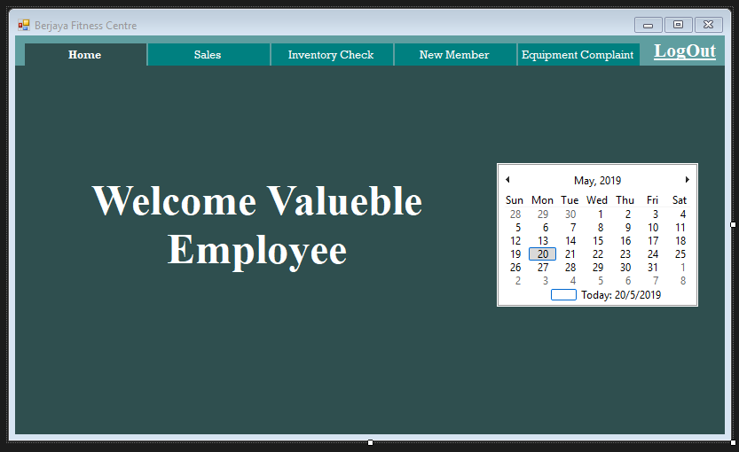

(7.f Staff Home Page)

Similar to the other home page, this one is for the staffs working in the gym.

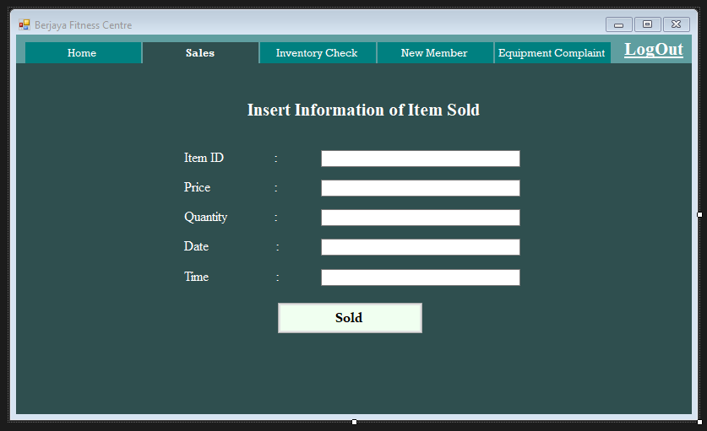

(7.g Staff Sold Item Page)

Items that have been bought by the customers will be scanned and all the item details will be stored here. If manual input is needed, staffs will have to type it by themselves.

**Input:** ItemID, Price, Quantity, Date, and Time item is sold.

**Output:** The information of the item sold will be listed down in the database and automatically updated to the system where it also let the staffs know the amount of stocks left the gym currently have.

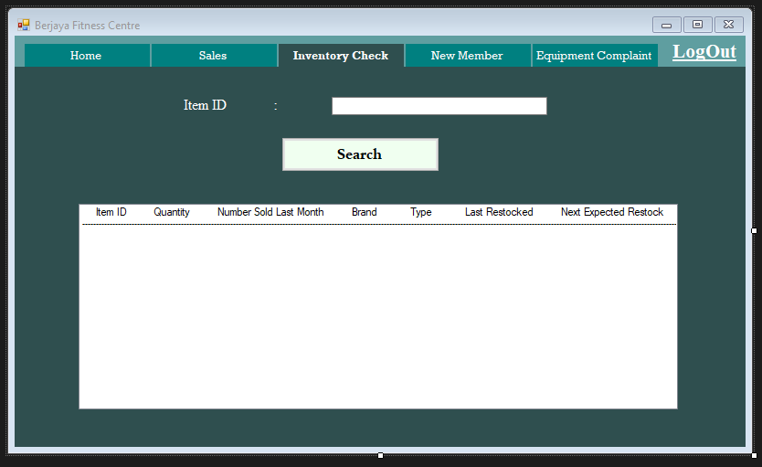

(7.h Inventory Check Page)

Staffs can check the item that are still available in the storage to keep track of the time when we must order for more stocks from the supplier.

**Input:** ItemID

**Output:** The item’s information.

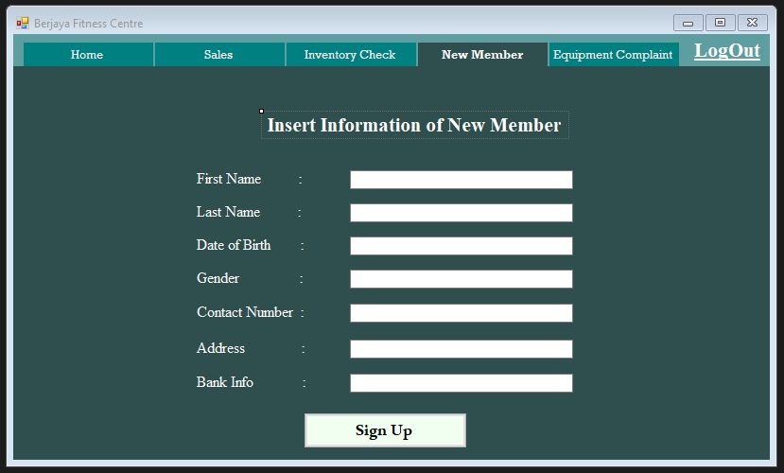

(7.i New Member Register Page)

Data of every new members that are joining the gym membership can be stored in the database through this window where staffs will input all the data given.

**Input:** All required information from the window.

**Output:** Information stored in the member database.

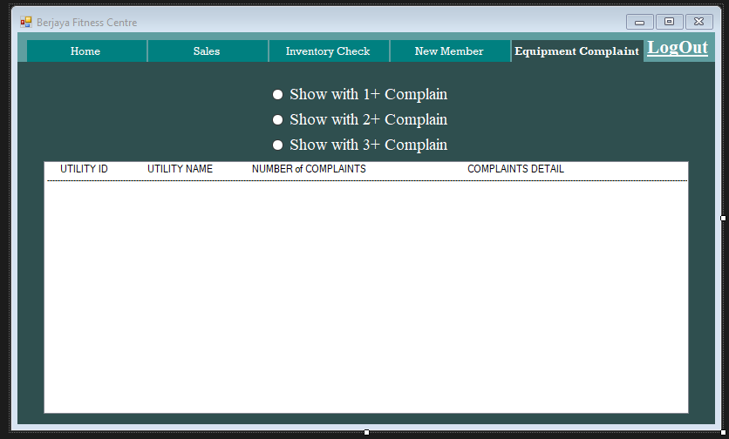

(7.j Equipment Complain Database Page)

All complaints of the gym equipment that have been submitted by the gym members will be shown here so that the staffs can immediately call the technician for help to fix it.

**Input:** Choose the number of complaints that the system received from the member that the staff would like to see.

**Output:** List of utilities that have broken down and details of the damages.

**For Gym Trainers**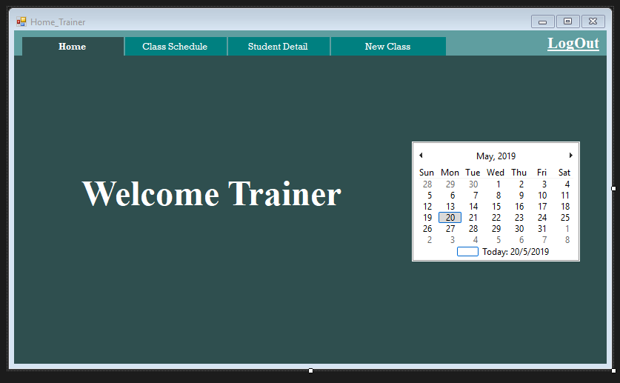

(7.k Trainer Home Page)

This is the home page for the gym trainers.

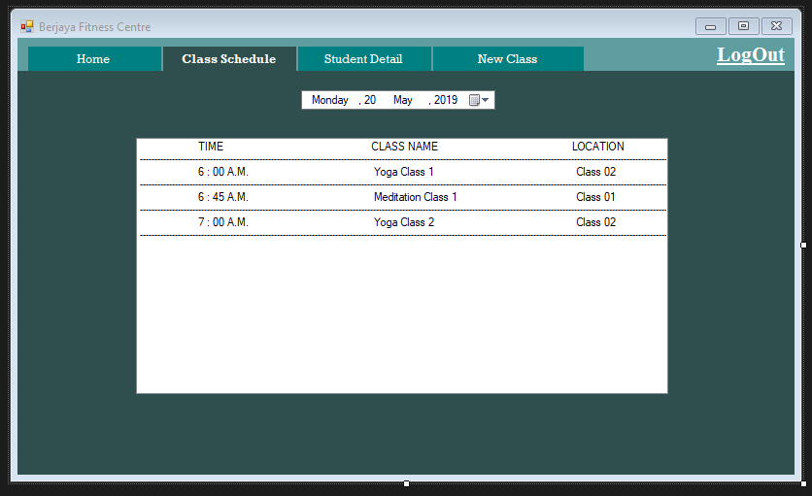

(7.l Trainer Class Schedule Page)

Each gym trainers’ appointments will be listed here as they must attend and teach the members that will attend the workout sessions later.

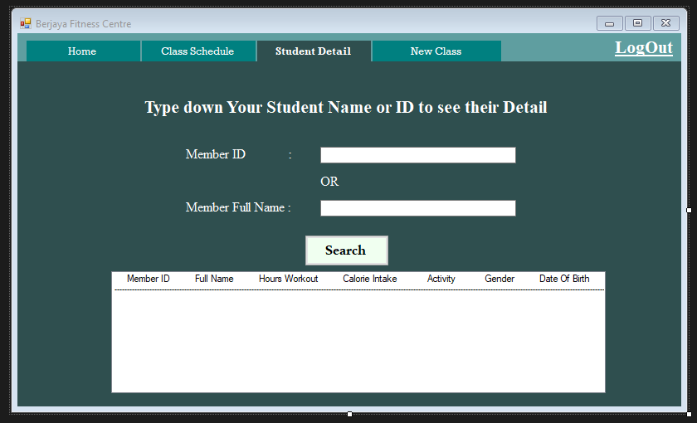

(7.m Trainer Student Detail Page)

Each trainer will be monitoring several gym members that has been hooked to them as their students. Therefore, this window is provided for the trainer to keep track of their students about how much calories they have taken each day and what activities they have done when the trainers are not around. Very useful to measure what kind of workouts that will be suitable for the students base on this data.

**Input:** Student ID and Name.

**Output:** Details of the student that the trainer currently monitors.

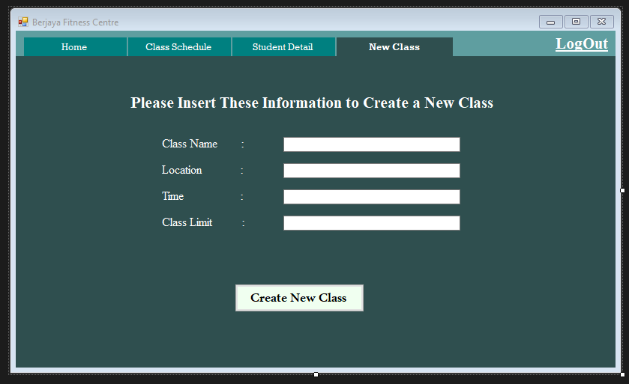

(7.n Trainer New Class Form Page)

Trainer can add extra classes that they would like to conduct for certain member or group teaching session.

**Input:** Class Name, Location, Time, and Limit person.

**Output:** This new class that the trainer has made will be broadcasted to the Classes window on the Member’s page to inform the gym members about it.

# Requirement Gathering

Observation : Matthew Axell (TP049057)

Interview : Ricky Marco (TP048884)

Survey and Questionnaires : Janice Lie (TP051250)

Research : Dakkshesh (TP053471)

Sampling :Jean-Paul Nathan Larue (TP052432)

Document Review : Jessica (TP051936)

## Observation

Observation to be the most suitable one. Observation is an information gathering method that questioner will observe all the user in the new and old system (staff, customer, etc). In this method the observer mainly focuses on how the users handles the process of the system. A benefit of this method is that the observer will get details when examining each person working with the system in personal level. There will be no steps in the processed not examined, and thus plentiful necessary information will be received by the observer.

In these observations, the observee will highly likely to have a good follow up when asked question during and after the observation. On the other hand, Observation has a negative impact on the information collected based on the observee, which is called the Hawthorne Effect. This effect changes the observee’s performance or productivity when they knew they are being observed. This will deviate the data to be misleading for the observer. Time and expense are required in high amounts when doing this method.

This method will be carried out by observing staff and members in the gym in their day to day routine using the old system. The observer will observe if any of its user will have any problem and noting that information. The Observer will also occasionally ask question to the users about the old system. These questions will be:

1.      From 1 to 10, rate your experience with the current system in the gym.

2.      If you can change a feature or two in the current system, what will be necessary?

3.      Can you say that the current system is efficient and helping you being productive in what you do in day to day activities?

4.      Rate how getting information out from this current system is easy or difficult from 1 to 10. 1 being easiest to 10 being hardest

5.      How has the current system helped or delay your work?

## Interview

Interview is a private meeting with two person or more where question are asked and answered. The person who asks the question is called interviewer and the person who answers the question is called interviewee. There are some purpose of performing interview such as to choose the right person to get into a company or to collect data from the interviewee, but in this case, we would want to use it to determine what future development that might be good for the company itself based on the opinion of subordinates or potential customers.

There are many benefits in implementing interview as the platform to gather information required and all of it depends on how we carry out the interview process. They include:

·        **Legit Information**

The individual that are being interviewed will unable to give false data in the screening question such as his origin, age, and gender where people usually provide the fake data to save time on answering question on surveys and complete the questionnaires as quick as possible. Even though the data provided may all be faithful, but in case we want categorize the answer, the data will be unreliable and deceptive.

·        **Evaluate mental state**

In the interviewing process, the verbal and non-verbal action of the interviewee will be monitored by the interviewer with no doubt. The body language that are shown by the interviewee can show the level of enthusiasm as well as comfort level that they feel whether they take the interview seriously or not.

·        **More focused**

The interviewer has the authority over the interview and when someone with such authority is sitting in front of us, we would like to behave well. In this case, interviewee might want to concentrate fully on the interview without any distraction such as texting to optimize the interview process.

·        **Building relationship**

In an interview, of course both sides will start to understand each other and increasing the relationships between them.

·        **Clarify misunderstandings**

There will be many respondents that will take part in the interviewing activity where each of them will translate each question differently. Hence, the interviewer will able to follow-up and explain directly to them about any question that they don’t understand so that we can get the answer we want.

Besides the advantages, there will be also some setbacks over the usage of the interview method which are:

·        **Cost**

In this method, a lot of money will be needed in order to run the interview. If we are not the one who conduct the interview, we will need to ask someone else or our staffs to replace us and it means we have to spend personnel cost for the time and energy that we took from them. Besides, additional interviewer can help increase the efficiency of the interview.

·        **Time consuming**

Time is the thing that matter the most in interviews. There are many people that will be interviewed and each of them can take a long time to complete. Not mention we have to wait for our turn to be interviewed because even if we have set the time for each person’s interview time, it will not be very accurate resulting the next person have to wait a little longer.

·        **Skills are needed**

We can’t just put any random staff to carry out the interview. Certain skills are needed to get the desired output such as communicating skill, data gathering skill, and patience. The interviewing staff will also have to avoid biases that could affect the way they input reactions. We can’t ignore this matter because it is the most likely to happen.

·        **Manual data input**

Information acquired from the interview are written in paper by the interviewer in the meantime. Therefore, we will have to hire additional staffs to help entering the data into the database which will increase the cost needed. The other technique to solve this problem is by giving the interviewer a tablet or other mobile devices where they can directly key in the data by themselves, but once again, it will consume a lot of time.

**Carrying out the interview**

Interview process will be done by the staffs from Atlas Company (System Analyst) in the Atlas office with the promise if they take part in the data collection process, they will be given a 1-month free access to the gym.

**Target users:**

-        Bodybuilders

-        Working staffs

-        Teenagers

-        Gym Trainers

-        Customer with the age above 30

**Questions**

**For Staffs and Gym Trainers:**

1.      What are the problems you have faced during the usage of this system?

2.      Which part of the system do you feel less effective in the activity of running this gym?

3.      What additional feature do you think we have to add in the system?

4.      Do you think the current system easy to be executed? Or are you comfortable in the process?

5.      What feature do you think is useless in the system?

**For Customers:**

1.      Do you have any problem following the current system of the gym?

2.      What additional feature do you think we have to add in the system?

3.      What feature do you think is useless in the system?

4.      Do you have any critics related to the system development project?

5.      From the scale of 1 to 10, rate the efficiency of the current system and why.

## Surveys and Questionnaires

For the information gathering of the Fitness Center System, I highly recommend using Surveys and Questionnaires method. Surveys and Questionnaires are one of fact-finding techniques that enable system analyst to gather information and viewpoints from large number of respondents in a fast and easy manner. Since the fitness centre have tight budget and time constraint, this technique of information gathering would match the project needs.

There are some benefits of using this method as follow:

* Inexpensive
* Quick to get results (possibly less than 24 hours)
* People can answer in a short time
* Allow for respondent anonymity
* No time constraint
* Responses can be reported and evaluated quickly

(Anvari.net, 2007)

Besides, some issues may occur while using this technique such as:

* Some questions may be left empty by the respondent
* Unable to give brief explanation of the misinterpreted question
* Bias answer from respondent (cannot observe respondent’s body language while answering the questionnaire)
* Differences toward the understanding of the question

(Home.kku.ac.th, 2010)

The advantages of applying this method surpasses the setbacks. Some of the setbacks also can be avoided if the series of the questions made are not ambiguous and the instructions given are clear & easy enough for people to understand. Therefore, this is the best information gathering technique for obtaining Berjaya Fitness Centre’s system requirements.

### Way to Conduct

One way to conduct a survey for collecting people’s interests and thoughts are through online since there are abundant of free online survey tools available on the internet which makes everything even easier for us to obtain information from those people. The target users for Berjaya Fitness Center may be people aged around 18 to 55 for both male and female who are aware of their health. To gather them, we will send the link containing questionnaires through email or post the link in Berjaya Fitness Centre’s social media page. Additionally, we can print a banner with a QR code attached on it then ask people to scan the code and do the survey. Put this banner in popular site on the weekend where the target users usually been. After the targeted audience finish answering all the questionnaires, give them a reward. In this case, the form of possible reward is a coupon to 3-day free trial to the gym.

Following that, analyse and write a report regarding to the results of the conducted survey. (Smartsurvey.co.uk, 2019)

Here are several questions could be used for the investigations.

* What is your gender?  (MCQ)
* How old are you? (range)
* What is your present weight? (range)
* What is your present height? (range)
* What is your occupation? (MCQ)
* How often do you usually exercise in a week? (MCQ)
* How frequently in a week do you usually go to the fitness centre? (range)
* Which one do you like better, to attend gym classes or independent trainings? (MCQ)
* What training classes are you most likely to attend? (MCQ)
* What type of gym equipment suits you? (MCQ)
* Do you consume health supplements? (yes or no)
* How much would be your budget for the gym membership? (range)
* What facilities you look forward for that cost?
* Do you want to work with personal trainers for reaching your fitness goals? (yes or no)
* Do you want to use an application for tracking your calorie loss? (yes or no)
* Rate the current fitness centre system based on your experience from the scale 1 to 10.
* How do you feel if we change the current system? (range)
* Do you want your trainer to be updated about your diet? (yes or no)
* From the scale 1 to 10, how an application would help you with your activities in the gym centre? (with 1= the worst and 10= the best)

## Research

For the information gathering of the Fitness Centre System, I would recommend using research. Research is one of the fact -finding techniques and as easy as it sounds, Research simply means the systematic investigation and a study of materials and sources in order to establish facts and to conclude. Research can be done by journals, books and internet sites. There are some benefits of applying research as the method of gathering information and they are as listed below.

The benefits of the research method as follows;

• High level of reliability

• Inexpensive

• Easier to access to the information

• Gets information fast

• Quick and easy to obtain

• Deeper understanding of the subject.

• Research gives you the ability to form a stance on the subject and take sides

The setbacks of research may depend on the following factors;

• Subjects may not be truthful

• Information can be outdated

• Confidentiality can be an issue

• Sometimes results are not repeatable and cannot be replicated.

• Some questions may be left with no research

• Time consuming

### Way to Conduct

One of the ways to conduct this research for collecting people’s opinions, idea and interest are through internet sites as the internet have every source available for us today. There are many independent firms that provide information which are available on the internet site. The target user for this fitness centre is people from the age of 18 all the way up to 60. This is applicable to both male and female who are concerned about their health and who wants to be fit and be healthy. We are also planning to target body builders. To conduct this and gather them, it would be easy to send out the invitation online through social media with a QR code attached to it. As a strategy, it will be said that by scanning the QR code and signing up, they are entitled to bring a friend along with them who gets a 15-day trial. Based on the research, write a report based on the conducted research.

Below are the questions used for the investigation:

1. What is the age most people go to gym?
2. Do people consume health supplements?
3. Would people be interested in calculating calorie loss applications?
4. What are the problems faced during the usage of the system?
5. What feature do you think is missing?
6. From the scale of 1 to 10, rate the efficiency of this system and why?

## Sampling

Sampling can be defined as a procedure in which a sample is selected from an individual or a group of people of certain kinds of research purpose.

It can also be described as a process of selection of limited number of elements from large group of elements, for example, population, so that the characteristics of the samples taken is identical to that of the population. (Raj, 2019)

How does it work?

Firstly, a basis of sampling needs to be chosen, a basic rule or way to determine how the sampling should be undergone. Once, the proper method of sampling has been chosen, selecting the appropriate samples according to the sampling method is a must. This is the most crucial part of the whole process, as it is the part which will describe the group to be sampled and whether it is accurate.

**Advantages of Sampling.**

1. Sampling deals with small proportions of a population. This means that costs will be lower than if sampling dealt with large populations, which is a bonus for companies as they would not have to pay for much sampling.
2. With the use of sampling, it will be less time consuming. It even takes less time than more techniques such as Tabulation.
3. Basically, a sample shows the population which is drawn from. This allows the sample to have a higher accuracy due to the limited area of operations.
4. Resources in an organization may be limited or exhausted, but lucky, sampling covers the population in a satisfactory manner. Sampling is an appropriate strategy when conducting marketing research.

**Disadvantages of Sampling**

1. The main issue with sampling is that it involves biased selection. Smaller samples are more reliable than larger samples.
2. Selecting good samples are difficult.
3. With the use of sampling method, it requires adequate knowledge. It involves statistical analysis and calculation of probable errors. A researcher who does not have knowledge in sampling may commit serious mistakes and errors.
4. In some cases, where high accuracy is needed or is a must, the sampling method may be unsuitable.

(Farooq,2013)

## Document Review

To gather information for the Fitness Center System, I suggest using document review method. Document review is a method to gather information by reviewing existing documents. This method is usually used to gather background information, decide whether execution of the program reflects program plans, help people in developing other information collection tools for evaluation, and collect information to answer what and how many evaluation questions. Due to these reasons, I think document review method is suitable for the information gathering.

Some advantages of using document review are:

* Low-cost
* Accurate background information
* Do not attract too much attention
* Give a behind-the-scenes view at a program that is not directly observable
* May raise issues not noted by different methods

Beside the benefits, there are some disadvantages of this method such as:

* Information may be too old, inaccessible, disorganized, and inapplicable
* Time consuming
* Information may be wrong and incomplete
* May be biased due to selective existing files or records

(Temporary Legal Staffing, 2019)

### Way to Conduct

There are five steps to conduct document review information gathering method:

1. Evaluating existing documents by looking at what kinds of information exist and decide which will answer the evaluation questions.
2. Secure access to the documents that have been distinguished through evaluation.
3. Protect the confidentiality of the documents because it is the most important consideration when collecting information for evaluation.
4. Compile the documents so that only the one that answer evaluation questions are reviewed.
5. Then, understand why and how the documents are made.

(Cdc.gov, 2019)

Several questions that can be used for the investigations are:

* Do you conduct background check on the fitness center?
* Do your reviewers have document review experience, and if so, how much?
* Can you accommodate off-hour access?
* What security measures do you employ at your fitness center?
* What are the operating hours of the fitness center?
* How are review rates monitored?
* How are deadlines and review standards communicated to review staff?
* How is your pricing structured?
* What type of expert advisory services do you offer?
* What is the advantage of working with you rather than one of your competitors?

(Unitedlanguagegroup.com, 2019)

# Individual Design

## DFD Level - 1

1.0 Customer Management System : Dakkshesh (TP053471)

2.0 Sales Management System : Ricky Marco (TP048884)

3.0 Supply Management System : Jessica (TP0)

4.0 Employee Management System : Janice Lie (TP051250)

5.0 Utility Management System : Matthew Axell (TP049057)

6.0 Accounting Management System : Jean-Paul (TP0)

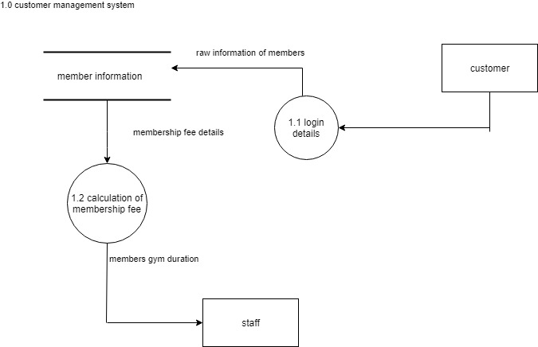

(1.0 Customer Management System)

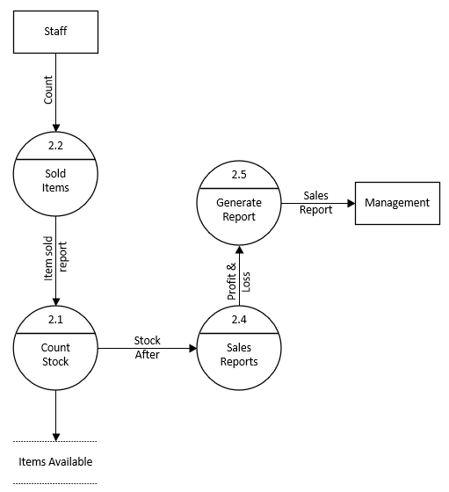

***(2.0 Sales Management System)***

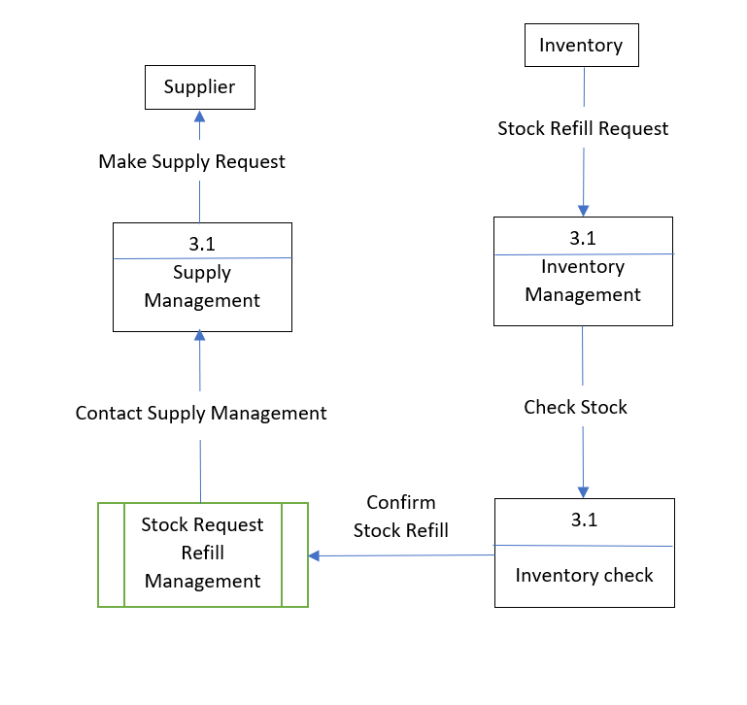

(3.0 Supply Management System)

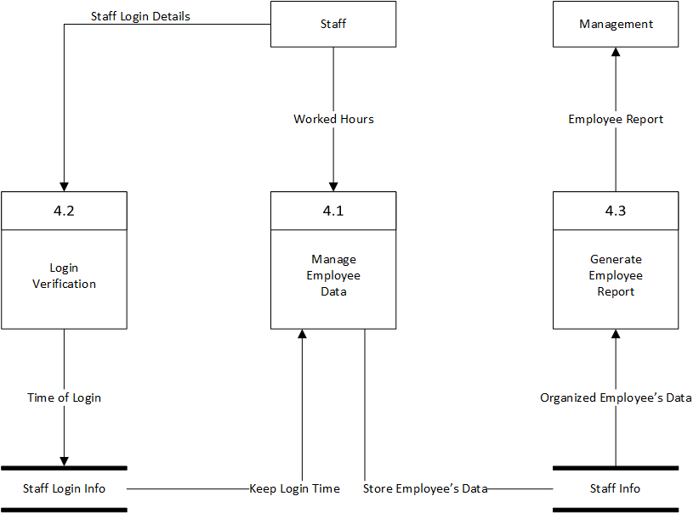

(4.0 Employee Management System)

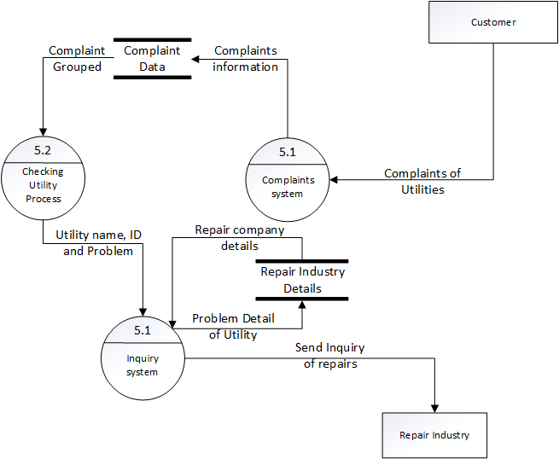(5.0 Utility Management System)

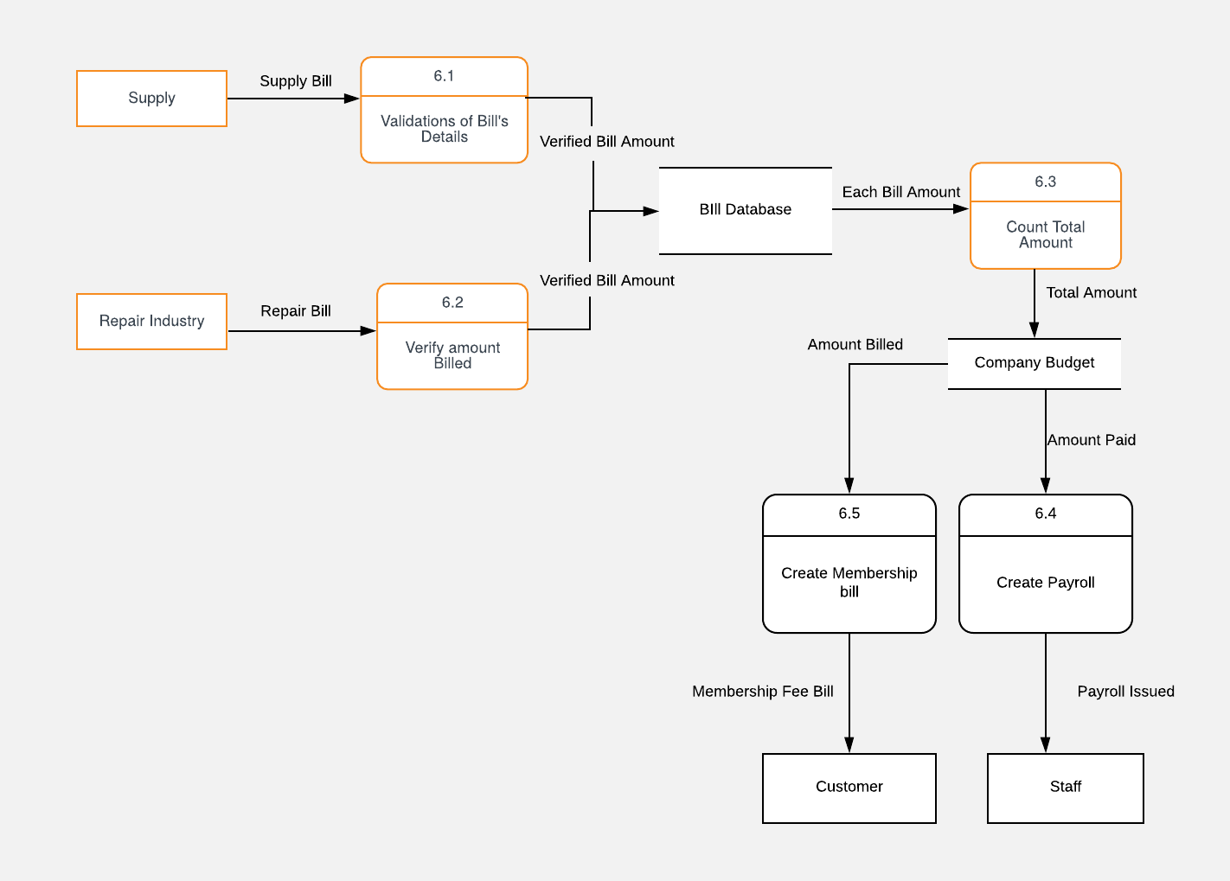

(6.0 Accounting Management System)

## Data Dictionary

1. **Janice Lie (TP051250):**

**Process:** 4.0 Employee Management System

|  |  |
| --- | --- |
| **Name** | Process 4.0 Employee Management System |
| **Description** | Used to process staff login details as well as   worked hours and generate a report to Management |
| **Input Data Flows** | Staff Login Details, and Hours Worked |
| **Output Data Flows** | Employee Report |
| **Process Description** | Manage all the staff login details including hours worked for each employee and create reports |

**External Entity:** Supplier

|  |  |
| --- | --- |
| **Name** | Supplier |
| **Description** | Supplier accept supply request and sends out supply bill based on how many stuffs have been ordered |
| **Input Data Flows** | Supply Request |
| **Output Data Flows** | Supply Bill |

1. **Matthew Axell (TP049057)**

**Data Flow:** Inquiry of Repairs

|  |  |
| --- | --- |
| **Name** | Inquiry of Repairs |
| **Description** | To allow the gym centre to send a inquiry to the Repair Industry according to the equipment |
| **Origin** | Utility Management System |
| **Destination** | Repair Industry |
| **Data Structure** | Utility Equipment Information, Complaints, Gym Information |

**External Entity:** Repair Industry

|  |  |
| --- | --- |
| **Name** | Repair Industry |
| **Description** | The Repair Industry receives the Inquiry of Repairs. After fixing the equipment, sends the Repair Bill. |
| **Input Data Flows** | Inquiry of Repairs |
| **Output Data Flows** | Repair Bill |

1. **Ricky Marco (TP048884)**

**Data Flow:** Sales Report System

|  |  |
| --- | --- |
| **Name** | Sales Report System |
| **Description** | To give information about sales and stock to the Supplier and the Manager |
| **Input Data Flows** | Sold items |
| **Output Data Flows** | Sales Report, Items Available |
| **Process Description** | Input the items that have been sold in the gym to the system and then it will automatically generate Sales Report and list out what items are still available |

**External Entity:** Manager

|  |  |
| --- | --- |
| **Name** | Manager |
| **Description** | Manager receives sales report and then decide what move to be made next after they review the report |
| **Input Data Flows** | Sales Report |
| **Output Data Flows** | TBD |

1. **Dakkshesh (TP053471)**

**External Entity:** Customer

|  |  |
| --- | --- |
| **Name** | Customer |
| **Description** | Customer would have to login as member and update details |
| **Input Data Flows** | Membership fee bill |
| **Output Data Flows** | Calorie intake and membership login details |

**Process:** 1.0 Customer Management System

|  |  |
| --- | --- |
| **Name** | 1.0 Customer Management System |
| **Description** | Used to process customer login details as well as membership fee and calorie intake |
| **Input Data Flows** | Member login details, calorie intake, membership fee bill, organised member information, new member data |
| **Output Data Flows** | Raw member information |
| **Process Description** | Manage information of customers along with membership data and any other relevant information |

1. **Jessica (TP051936)**

**Process**: 3.0 Supply Management System

|  |  |
| --- | --- |
| **Name** | Process 3.0 Supply Management System |
| **Description** | Used to process refill stock request and supply request |
| **Input Data Flows** | Refill Stock Request |
| **Output Data Flows** | Supply Request |
| **Process Description** | Manage request to refill stocks from inventory and make supply request to supplier |

**External Entity**: Staff

|  |  |
| --- | --- |
| Name | Staff |
| Description | Staff handle payroll issued and product sales, input new member data, manage staff login details and work hours, and record member’s in and out hours |
| Input Data Flows | Payroll Issued |
| Output Data Flows | Staff Login Details, Hours Worked, Product Sales, New Member Data, Member’s In and Out Hours |

1. **Jean-Paul Nathan Larue (TP052432)**

**Process:** 1.0 Accounting Management System

|  |  |
| --- | --- |
| **Name** | Accounting Management System |
| **Description** | Used to process bills such as supply and repair. |
| **Input Data Flows** | Supply Bill and Repair Bill |
| **Output Data Flows** | Verified Bill Amounts |
| **Process Description** | Each bill is verified and once that is done. It is recorded into the Bill Database so that it can be stored for future purposes. Then the total of the Bill database is calculated then, processed to the companies budget. |

**External Entity: Company Budget**

|  |  |
| --- | --- |
| **Name** | Company Budget |
| **Description** | Here is where the company would decide on the membership bills and the payroll bills. These would depend on the companies budget. If too low then for example, the company can increase the membership bills to obtain some revenue. |
| **Input Data Flows** | Company Budget |
| **Output Data Flows** | Membership Fee bill to the customer and Payroll bills to the employees. |

# References:

Anvari.net. (2007). [online] Available at: http://www.anvari.net/CIS210%5CCIS210Spring08%5CInstructors%20Manual/Chap06.pdf [Accessed 17 May 2019].

Chand, S., (n.d). *Interview: Definition, Objectives, Types and Guidelines for Effective Interviewing.* [Online] Available at: http://www.yourarticlelibrary.com/hrm/interview-definition-objectives-types-and-guidelines-for-effective-interviewing/35268

[Accessed 16 05 2018].

Cdc.gov. (2019). [online] Available at: https://www.cdc.gov/healthyyouth/evaluation/pdf/brief18.pdf [Accessed 9 Jun. 2019].

Unitedlanguagegroup.com. (2019). [online] Available at: https://unitedlanguagegroup.com/wp-content/uploads/2017/02/ebook-12.pdf [Accessed 9 Jun. 2019].

DeFranzo, S. E., (2014). *Advantages and Disadvantages of Face-to-Face Data Collection.* [Online] Available at: https://www.snapsurveys.com/blog/advantages-disadvantages-facetoface-data-collection/

[Accessed 17 05 2019].

Farroq,U ( June, 2013) Advantages and Disadvantages of Sampling Data Collection

http://www.studylecturenotes.com/social-research-methodology/advantages-disadvantages-of-sampling-method-of-data-collection

(Accessed 09/06/2019)

Home.kku.ac.th. (2010). [online] Available at: https://home.kku.ac.th/wichuda/Sa/Slide/MIT/MIT_C2Fact.pdf

[Accessed 17 May 2019].

Perfect Gym. (2019). *7 Helpful Fitness Survey Ideas & Examples*. [online] Available at: https://www.perfectgym.com/en/blog/business/6-helpful-fitness-survey-ideas-examples [Accessed 17 May 2019].

Smartsurvey.co.uk. (2019). *6 Steps To Conducting An Online Survey | SmartSurvey*. [online] Available at: https://www.smartsurvey.co.uk/articles/6-steps-to-conducting-an-online-survey [Accessed 17 May 2019].

Raj, B (2019) Sampling: Definition, Advantages and Disadvantages. Available at

https://www.mathstopia.net/sampling/definition-advantages-disadvantages

(Accessed 09/06/2019)

Temporary Legal Staffing. (2019). *﻿Understanding Document Review Work (Benefits and Disadvantages)*. [online] Available at: https://temporarylegalstaffing.weebly.com/blog/understanding-document-review-work-benefits-and-disadvantages [Accessed 9 Jun. 2019].

The Business Communication, (n.d). *What is interview? Types of interviews.* [Online]

Available at: https://thebusinesscommunication.com/what-is-interview-types-of-interviews/

[Accessed 16 05 2018].

# Appendix

## Workload Matrix

|  |  |  |  |  |  |  |
| --- | --- | --- | --- | --- | --- | --- |
| Group Member | Jessica  **TP051936** | Janice Lie  **TP051250** | Jean-Paul  **TP052432** | Dakkshesh  **TP053471** | Matthew Axell  **TP049057** | Ricky Marco  **TP048884** |
| Introduction | **16.66%** | **16.66%** | **16.66%** | **16.66%** | **16.7%** | **16.66%** |
| Problems and Proposed Solutions | **50%** | **50%** |  |  |  |  |
| Project Planning |  |  | **50%** | **50%** |  |  |
| Feasibility Study | **50%** | **50%** |  |  |  |  |
| Systems Analysis |  |  | **50%** | **50%** |  |  |
| Design Diagram |  |  |  |  | **50%** | **50%** |
| Interface Design |  |  |  |  | **50%** | **50%** |
| **Total** | **16.66%** | **16.66%** | **16.66%** | **16.66%** | **16.7%** | **16.66%** |
| **Signature** |  |  |  |  |  |  |